**Ex. No.: 10b)**

**Date: 05-04-2025**

**FIRST FIT**

**Aim:**

To write a C program for implementation memory allocation methods for fixed partition

using first fit.

**Algorithm:**

1. Define the max as 25.

2: Declare the variable frag[max],b[max],f[max],i,j,nb,nf,temp, highest=0, bf[max],ff[max]. 3:

Get the number of blocks,files,size of the blocks using for loop.

4: In for loop check bf[j]!=1, if so temp=b[j]-f[i]

5: Check highest

**Program Code:**

#include <stdio.h>

#define max 25

int main() {

int frag[max], b[max], f[max], i, j, nb, nf, temp;

int bf[max], ff[max];

// Input

printf("Enter the number of blocks: ");

scanf("%d", &nb);

printf("Enter the size of the blocks:\n");

for (i = 0; i < nb; i++) {

printf("Block %d: ", i + 1);

scanf("%d", &b[i]);

bf[i] = 0; // initially all blocks are unallocated

}

printf("\nEnter the number of files: ");

scanf("%d", &nf);

printf("Enter the size of the files:\n");

for (i = 0; i < nf; i++) {

printf("File %d: ", i + 1);

scanf("%d", &f[i]);

}

// First Fit Allocation

for (i = 0; i < nf; i++) {

for (j = 0; j < nb; j++) {

if (bf[j] == 0 && b[j] >= f[i]) {

ff[i] = j;

frag[i] = b[j] - f[i];

bf[j] = 1; // mark block as allocated

break;

}

}

}

// Output

printf("\nFile_no\tFile_size\tBlock_no\tBlock_size\tFragment\n");

for (i = 0; i < nf; i++) {

printf("%d\t%d\t\t", i + 1, f[i]);

if (bf[ff[i]] == 1)

printf("%d\t\t%d\t\t%d\n", ff[i] + 1, b[ff[i]], frag[i]);

else

printf("Not Allocated\n");

}

return 0;

}

**OUTPUT:**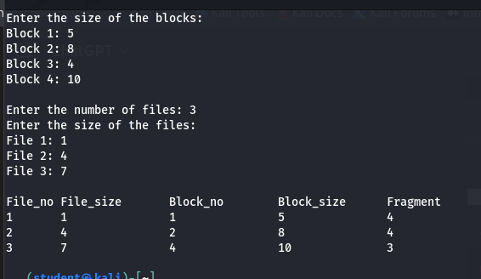

**RESULT:**

Hence, First Fit memory allocation technique using Python has been implemented.